Lizabeth
Jenkins-Dale,M.Ed.
Middle School Years Without Tears
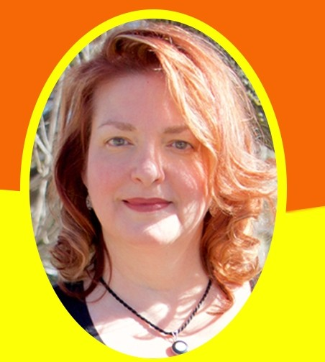Gttttn,g R,ady(A, Any Tm,t) ror Wo,,dtdul.
Awtoom .Su<'C'C'uful. and Thrilllng M,dd S<:ho>IE:xp.-" """'•'

AUTHOR OF MIDDLE SCHOOL YEARS WITHOUT TEARS LIZABETH JENKINS-DALE. M. ED.

